- NETWORK MONITORING AND TROUBLESHOOTING TOOLS ASSIGNMENT
Q1. Capture Network Traffic Using Wireshark
Objective: Capture about 2 minutes of your own network traffic while browsing Instagram or YouTube, save it as a .pcap file, and identify the top three protocols.
- Install Wireshark from its official website. During Windows installation, allow Npcap to be installed because Wireshark uses it for packet capture.
- Open Wireshark and select the active interface, usually Wi-Fi if the laptop is connected wirelessly.
- Double-click the active interface to start capturing packets.
- Open Instagram or YouTube in your browser and browse normally for about 2 minutes.
- Return to Wireshark and click the red Stop button.
- To see protocol statistics, open Statistics > Protocol Hierarchy and observe the protocols shown in the capture.
- Write down the top three protocols you observe. The exact protocols depend on your traffic; do not copy example results without checking your capture.
- Save the capture using File > Save As and choose the .pcap or .pcapng format requested by your trainer.
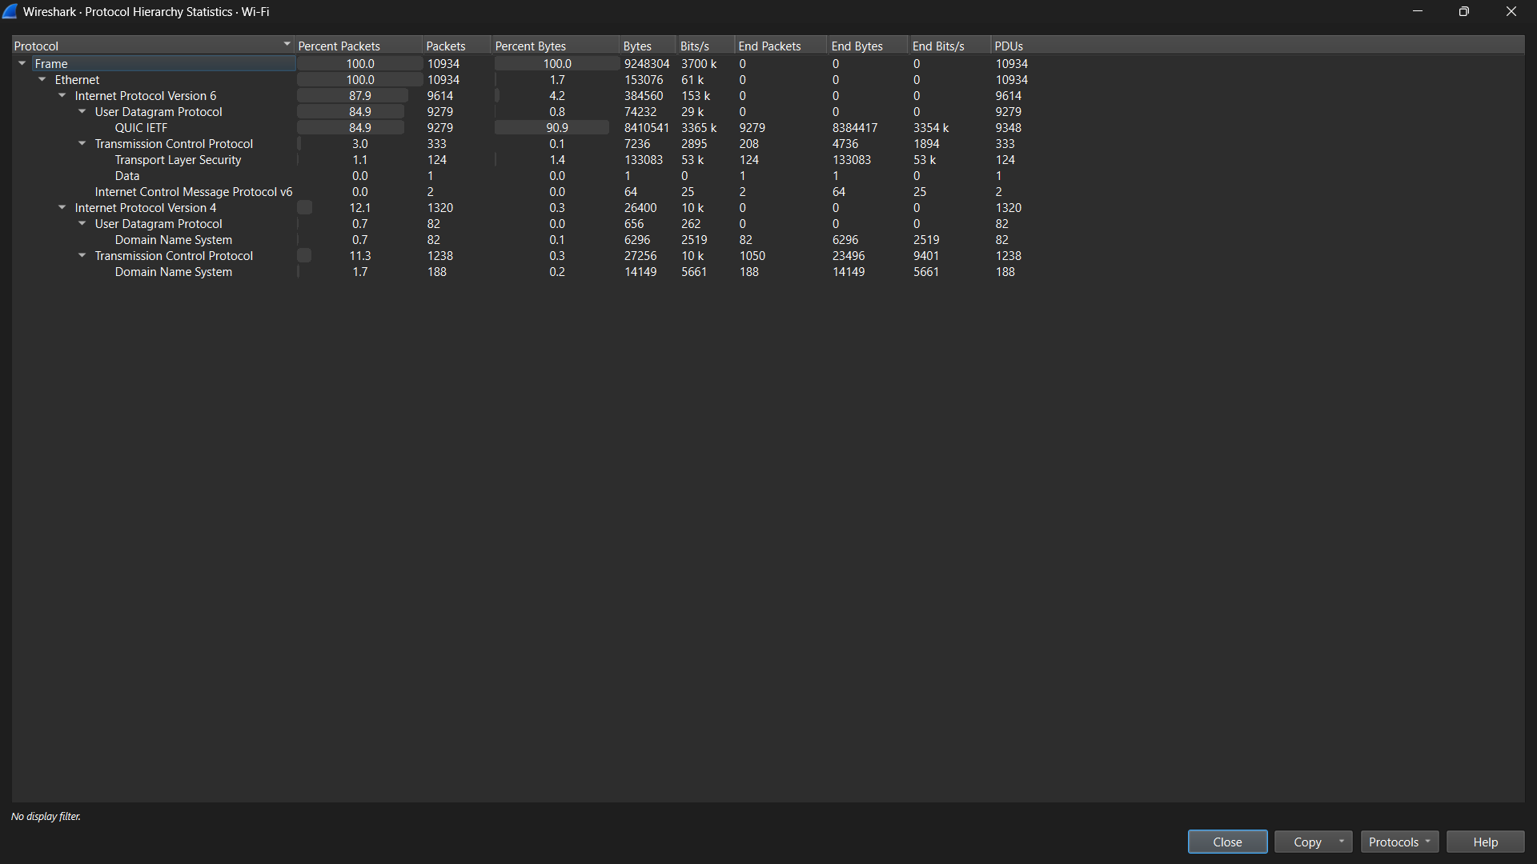
Q2. Test Spotify and Zomato Using ping
Open Command Prompt and run these commands one at a time:
ping www.spotify.com
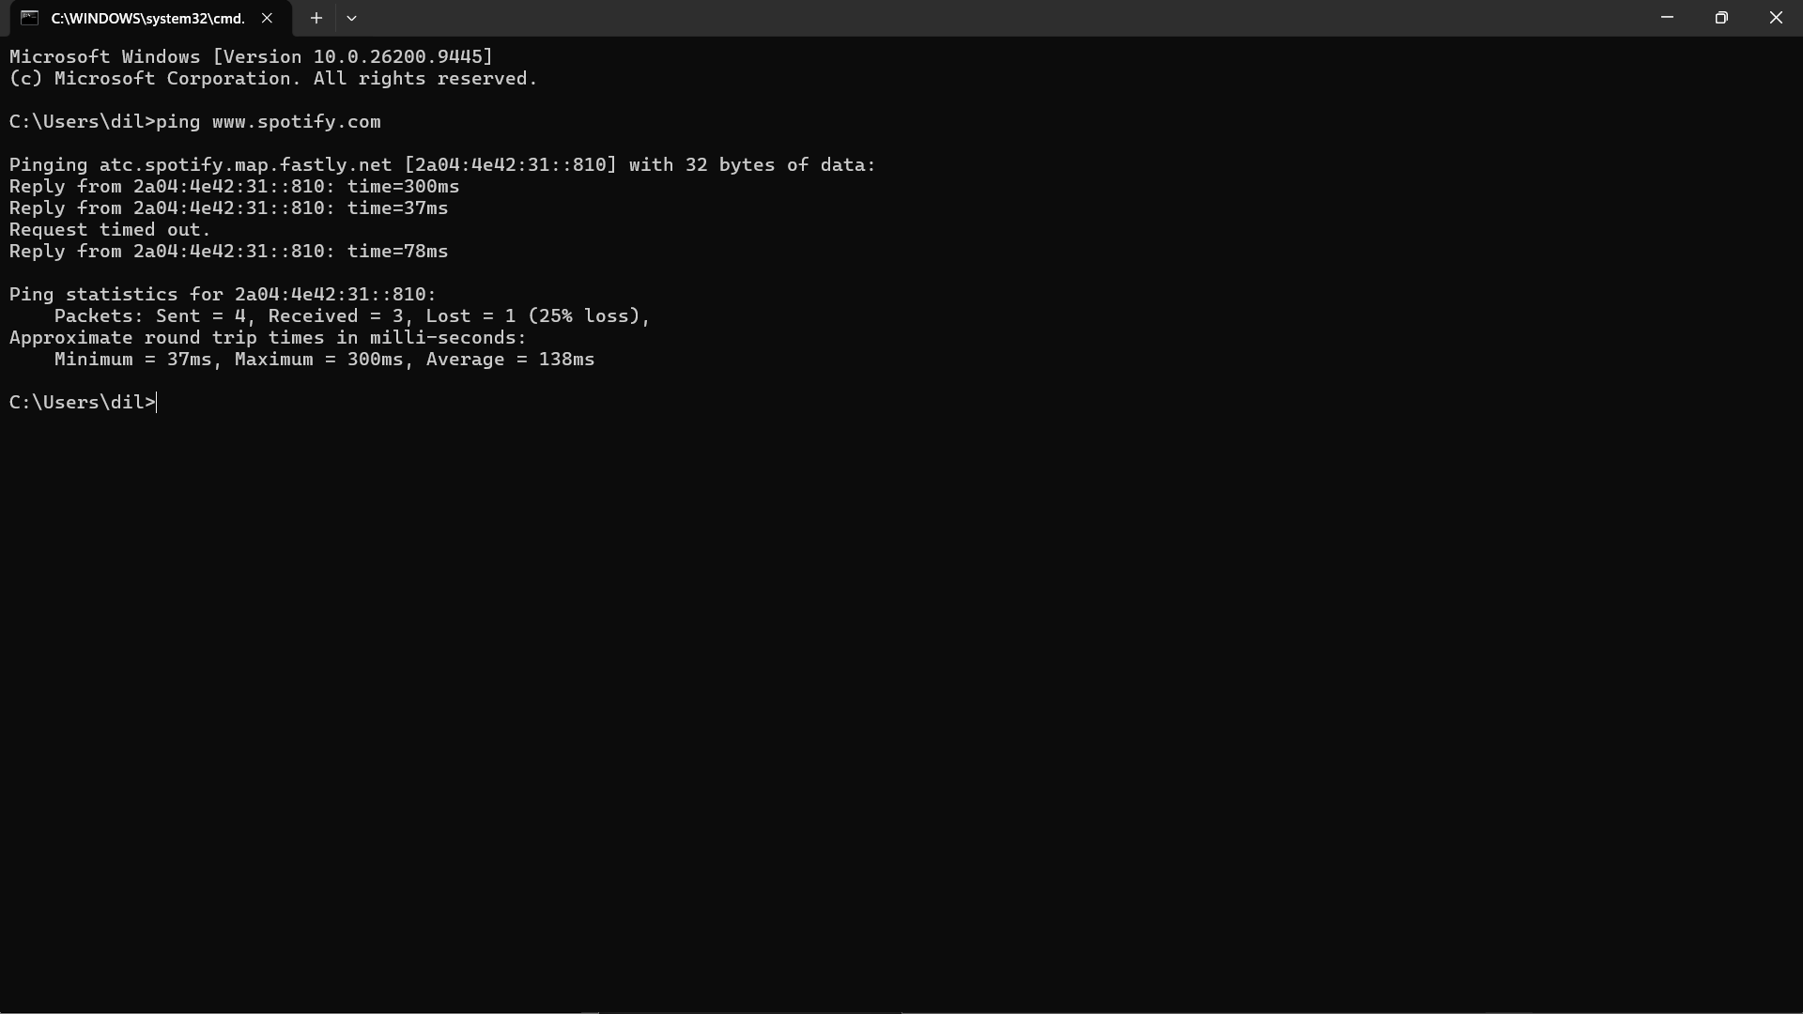
ping www.zomato.com
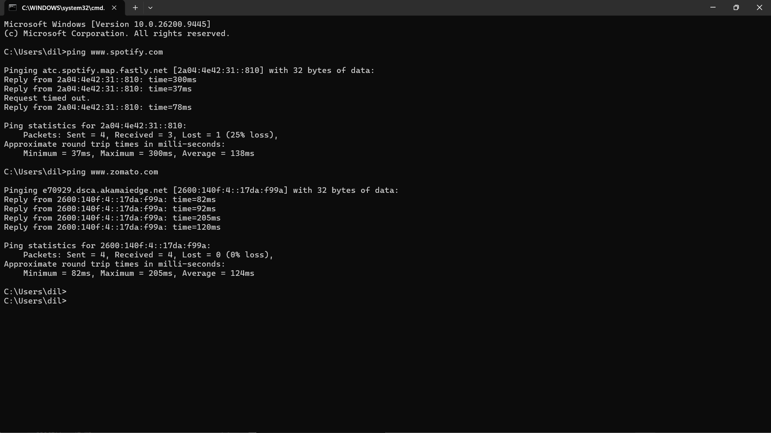
Q3. Check Running Processes in Windows Task Manager
- Press Ctrl + Shift + Esc to open Task Manager.
- Click Processes. If Task Manager is in a compact view, choose More details if available.
- Look for Chrome, WhatsApp, Microsoft Edge, or another browser-based application you use.
- Note the process/application name and the Memory value shown beside it.
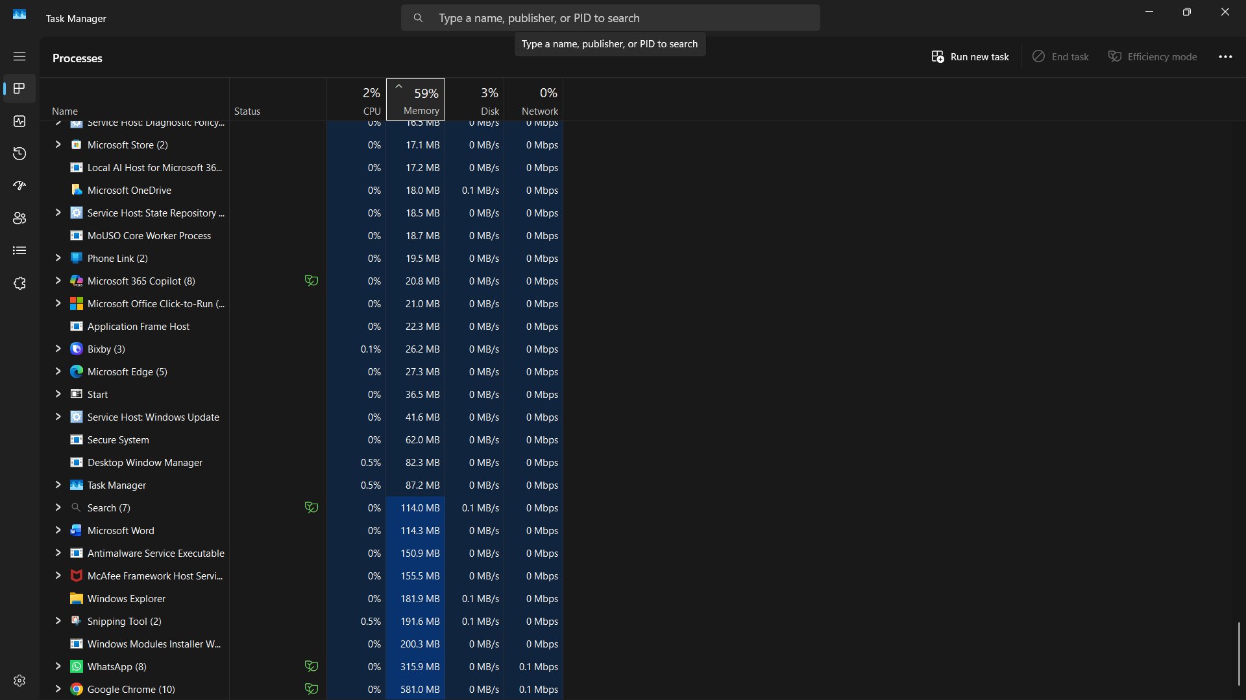
Q4. Scan Your Own Local Network Using an IP Scanner
Use this activity only on a network you own or have permission to scan, such as your own home Wi-Fi or an authorized college lab network.
- Install Angry IP Scanner or Advanced IP Scanner from its official source.
- Connect your laptop to your own Wi-Fi/network.
- Open Command Prompt and run ipconfig. Note your IPv4 address and subnet mask so you know your local network range.
- Open the scanner. Use only the local IP range belonging to your own network. Many scanners can detect the range automatically.
- Start the scan and wait for it to finish.
- From the results, identify at least two devices that you recognize or are authorized to document.
- Record only the IP address and device/host name required by the assignment. Avoid scanning networks for which you do not have permission.
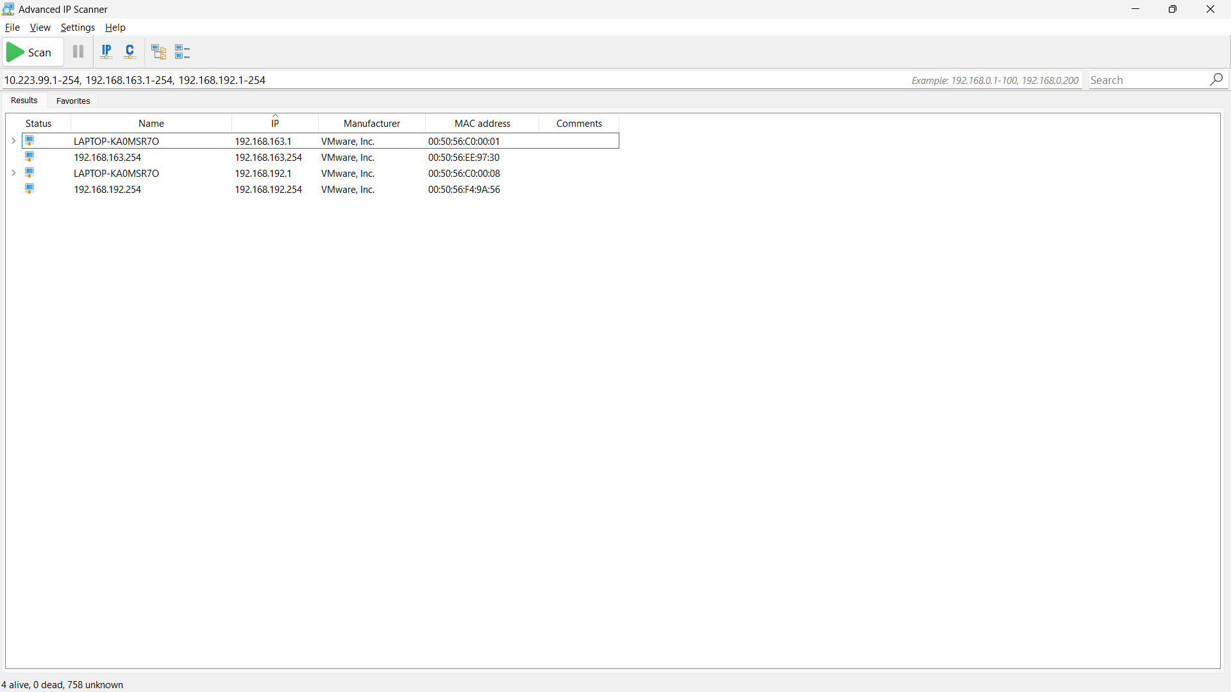

Q5. Three Hardware Tools Used in Network Troubleshooting.
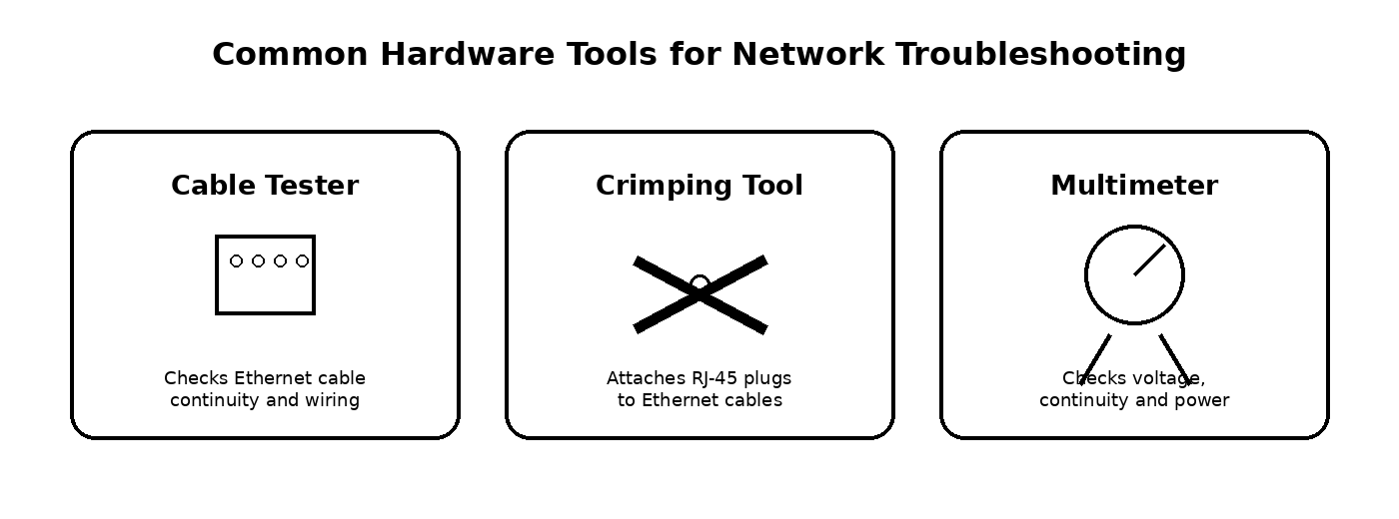
Hardware Tool | What It Does | When I Would Use It
Cable Tester | Tests Ethernet cable continuity and pin wiring. | I would use it when a LAN cable is connected but the device has no network link or the cable may be faulty.
Crimping Tool | Attaches an RJ-45 connector to twisted-pair Ethernet cable. | I would use it when making or repairing an Ethernet patch cable.
Multimeter | Measures electrical values such as voltage, resistance and continuity. | I would use it to check power supplies, continuity or electrical problems affecting network equipment.
Conclusion
Wireshark, ping, Task Manager and authorized IP-scanning tools help diagnose different parts of a network. Hardware tools such as cable testers, crimping tools and multimeters are useful when troubleshooting physical cabling and power-related problems.

